William Doudna

January 29, 2018

Adam Carter

Mobile Apps

Hangman

Summary: I initially wrote an isPrime app that would take in a user’s inputted number via an EditText and would then determine whether or not that number was prime. However, this app looked to simple and I decided that I wanted to something that was more satisfying. This led me into designing my hangman app. This is a simple app that is designed to be used by two people to play hangman with each other. I wrote this application because I wanted to get a decent grade on this homework while also making something that is at least kinda cool.

System Design:

* This app can run on a minimum SDK of API 17: Jelly bean
* For the purposes of saving space I have cropped the lower portion of these images that is normally filled with whitespace or the user keyboard
* Here is the initial screen users are prompted with upon opening the app

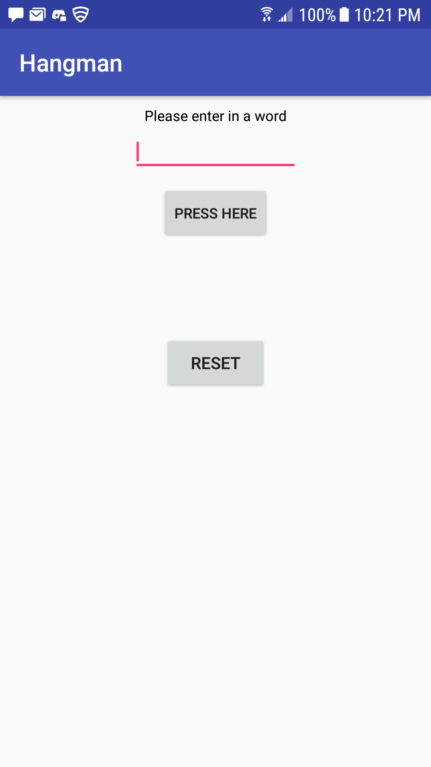

From here the user can enter in a word for their friend to guess or if they accidentally the ‘press here’ button before entering in a word, then it will prompt them to enter in a word first.

Normal word entry:

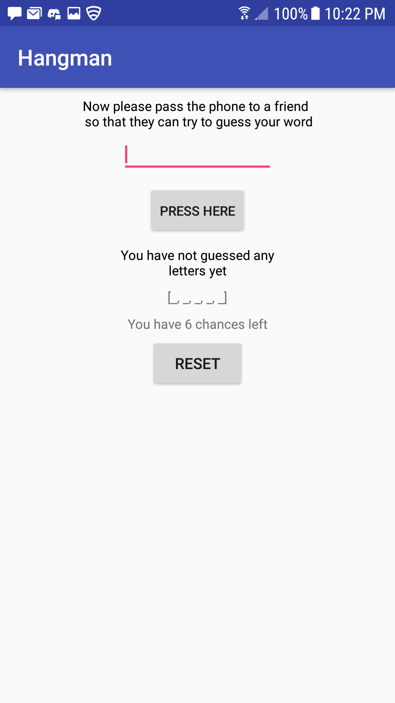

Blank word entry:

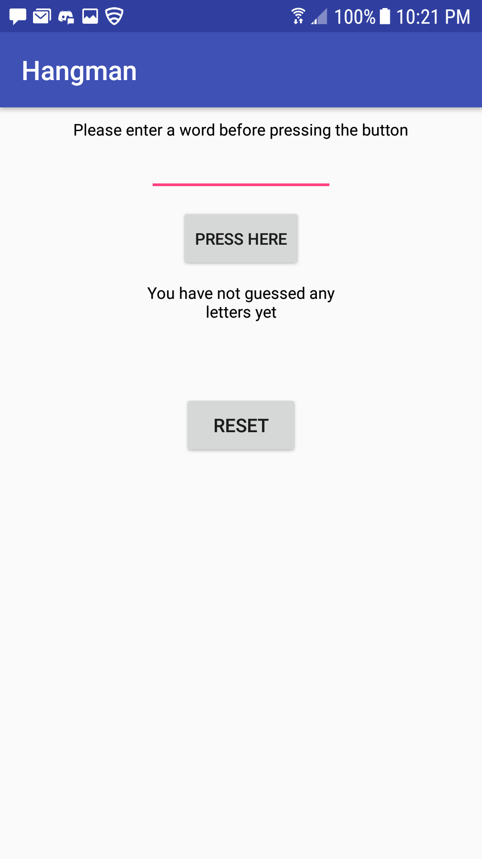

Once the user has successfully inputted a word and handed the device to a friend, their friend can either enter in nothing (user error), enter in a letter is within the guess-word (the word that the user’s friend is trying to guess), or enter a letter that is not within the guess-word.

Blank entry:

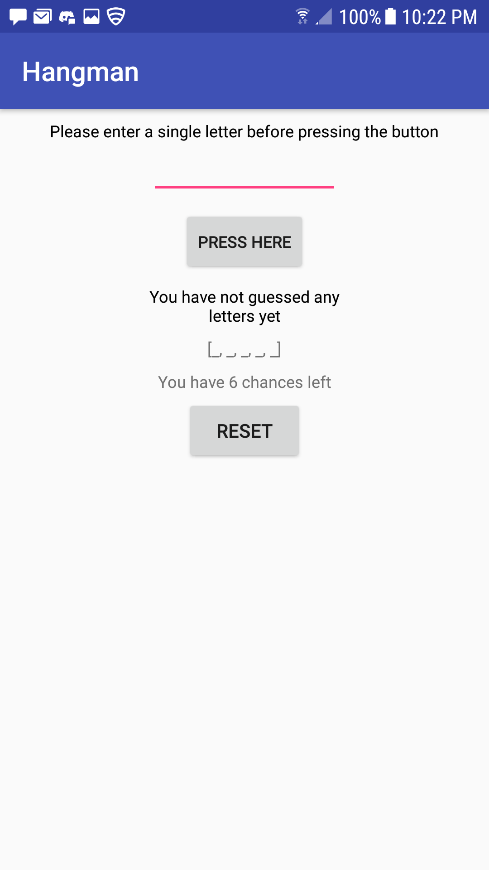

Correct guess: Notice that the correct guesses update both previous guesses and the correct guesses texts

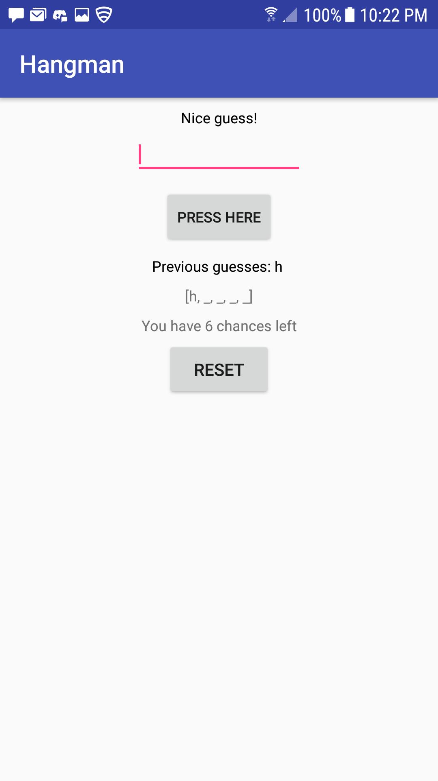

Incorrect guess: The chances counter decrements here and the incorrect letter appears in past guesses

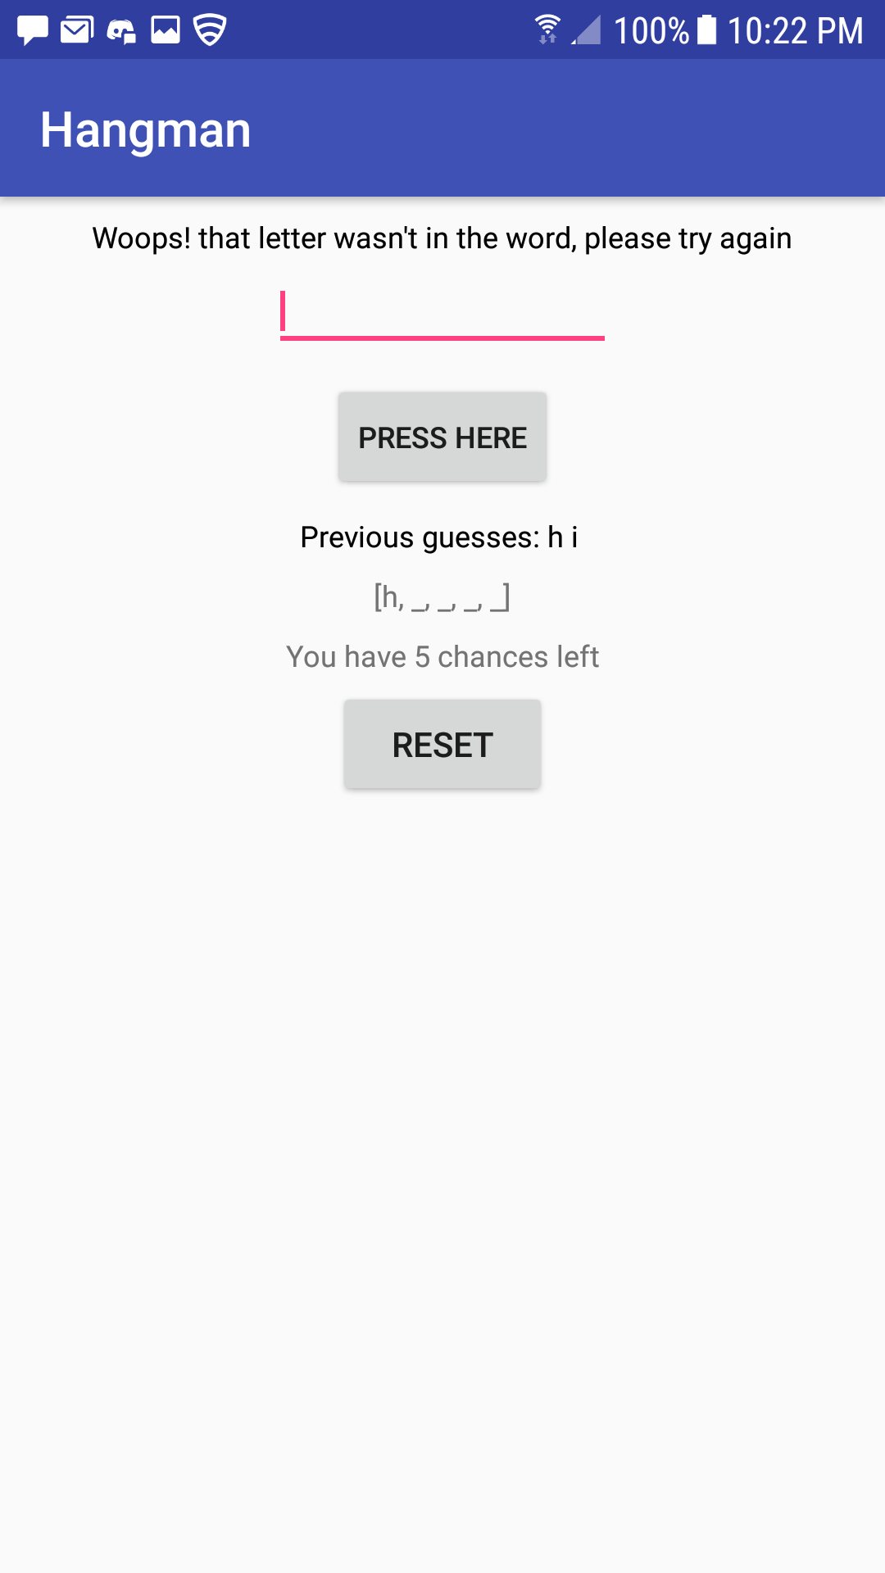

From here the user can either guess enough times to lose, or to eventually guess the word correctly.

Here is the UI after the user wins the game:

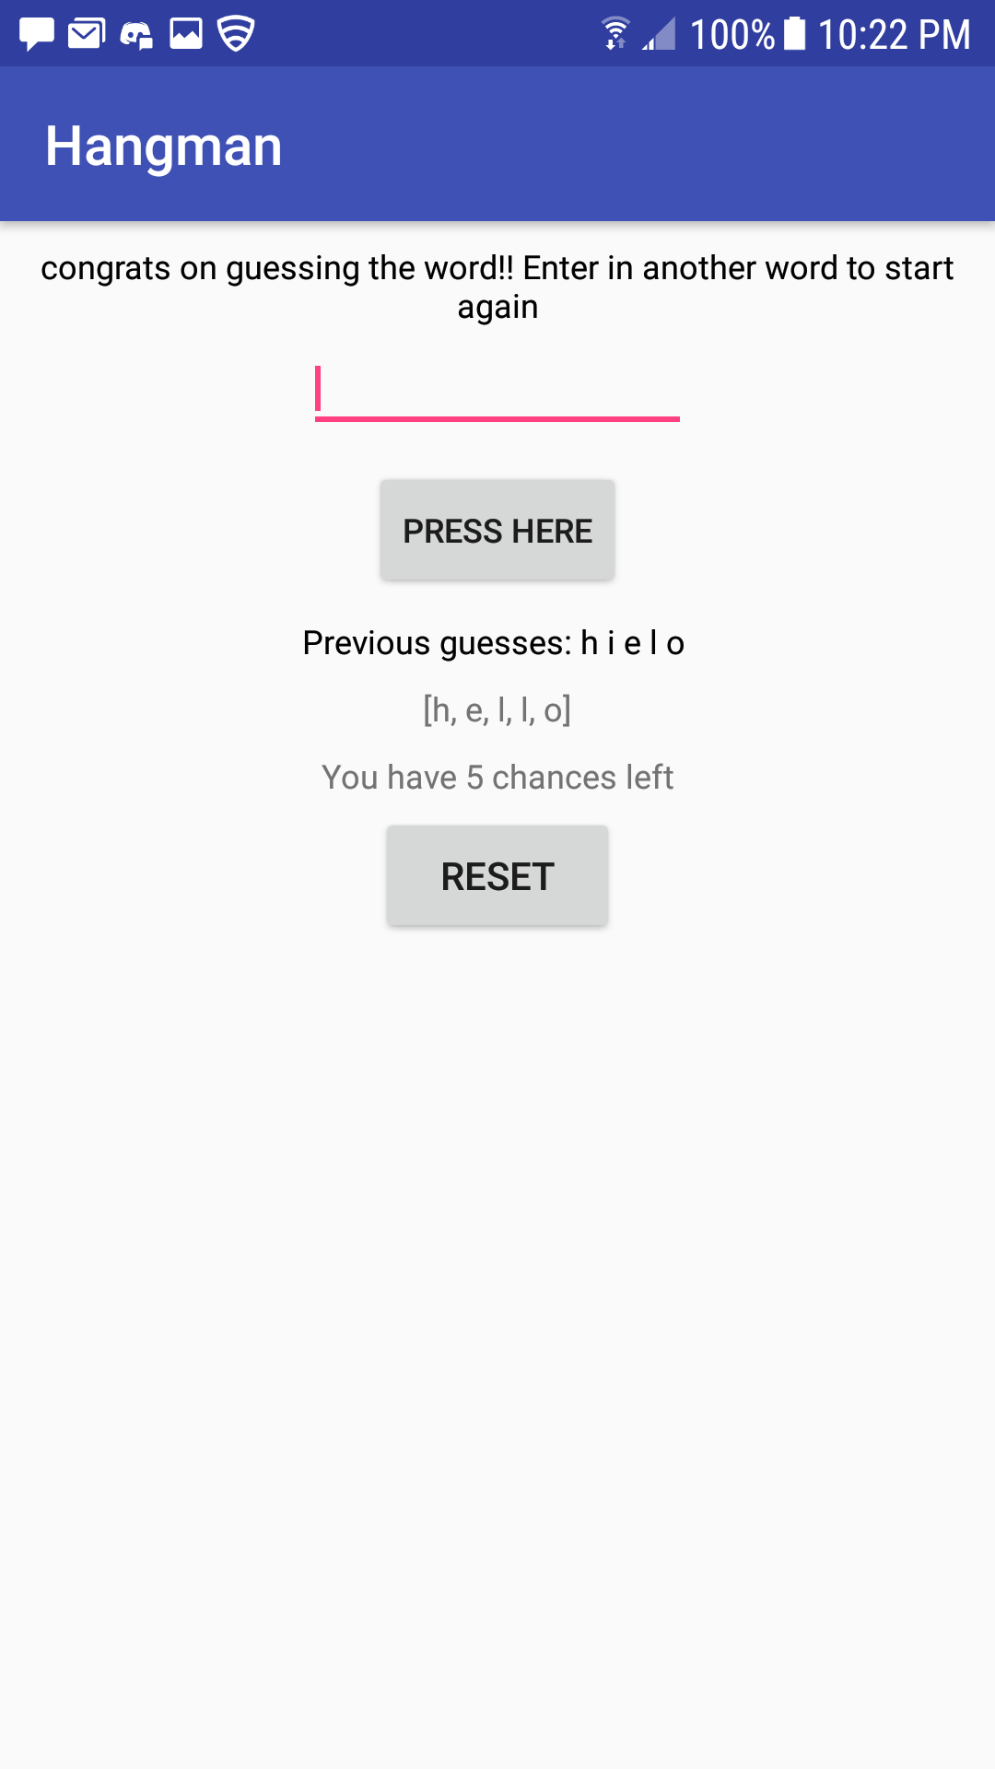

Here is the UI after a user loses the game by running out of chances:

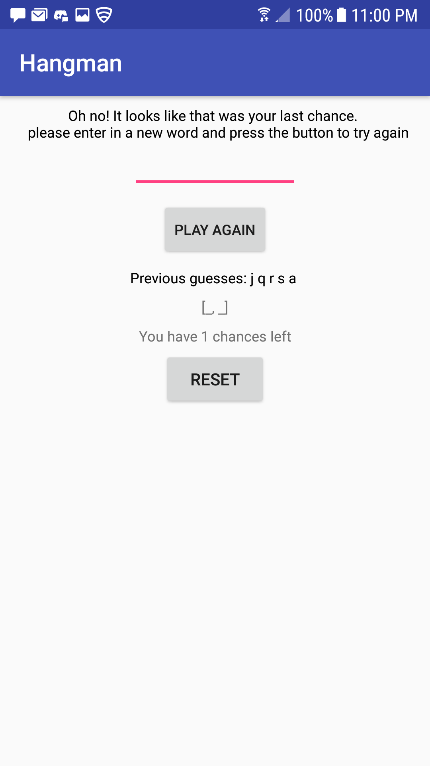

At any point it is also possible to reset the game by hitting the reset button. This will lead you to the following screen which allows you to input a new word to play again: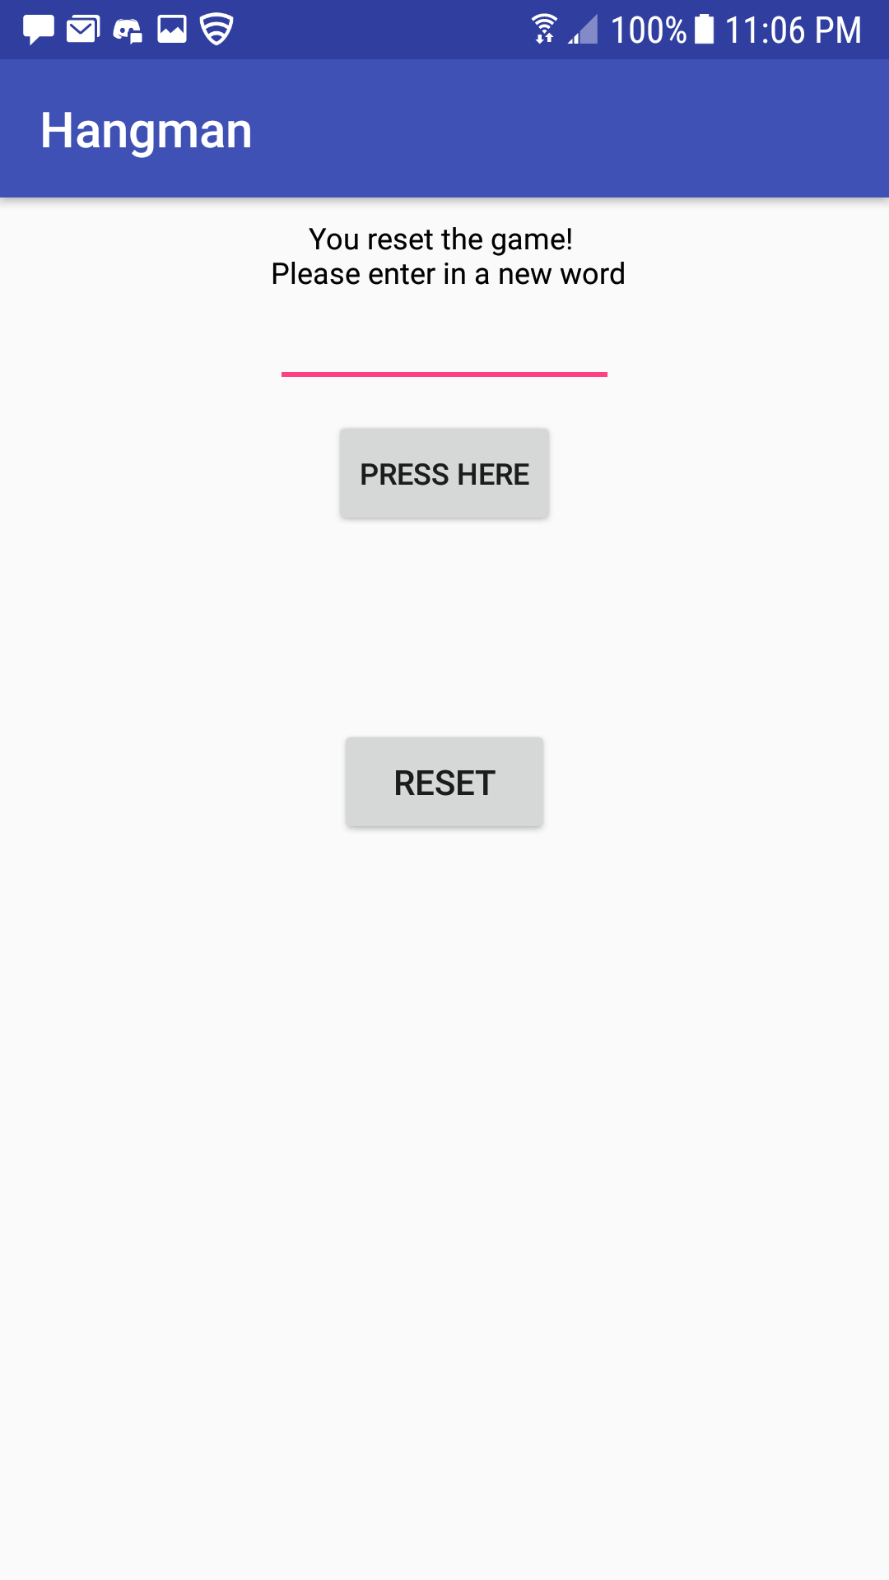

Usage

This game was designed after the pencil and paper game of hangman. This is a game that is designed to be played by 2 people, where one person picks a word and the other tries to guess it one letter at a time. After a certain number of incorrect guesses, the guesser loses. However if the guesser guesses the word before they run out of chances then they win the game. If any point the user wishes to enter in another word they can simply hit the reset button to start over